PHASE 2 - DESIGN
(Netflix Content Analytics Project)
Goal: Define the architecture, data flow, storage schema, and processing logic required for cleaning, transforming, and analyzing the Netflix dataset.
Phase 2 ensures that Phase 3 (Data Cleaning) and Phase 4 (Visualization) run smoothly with a clearly planned structure.

1. High-Level Architecture
Raw CSV → Data Cleaning Pipeline (Python) → Processed Datasets → Tableau Dashboard
Components:
- Raw Data Source
  - netflix_titles.csv from Kaggle
- Processing Layer (Python Scripts)
  - Cleaning
  - Feature extraction
  - Genre explosion
  - Duration numeric extraction
  - Date parsing
- Output Layer (Processed Data)
  - netflix_clean.csv
  - netflix_genres_exploded.csv
- Visualization Layer (Tableau)
  - KPI cards
  - Genre analysis
  - Time-series charts

2. Data Flow Diagram
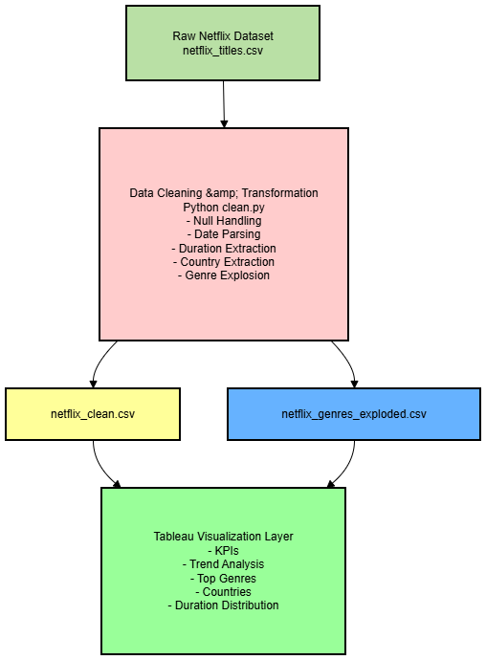

3. Data Model (Processed Tables)
3.1 Table 1: netflix_clean.csv
Column Name | Description
show_id | Unique identifier
title | Movie/Show title
type | Movie / TV Show
description | Description text
listed_in | Original genres string
primary_country | First country extracted
date_added | Cleaned date in YYYY-MM-DD
added_year | Extracted year
release_year | Year of release
duration | Original duration string
duration_num | Extracted numeric duration
duration_type | Minutes / Seasons
rating | Maturity rating
Purpose:
Used for KPIs, time-series, country analysis, ratings, and movie duration visualizations.

3.2 Table 2: netflix_genres_exploded.csv
Column Name | Description
show_id | Foreign key to netflix_clean
genre | One genre per row
title | Title (for reference)
Purpose:
Used exclusively for genre-level analytics (Top 10 genres).
4. Cleaning & Transformation Logic
4.1 Missing Value Handling
- Drop records where show_id is missing.
- Fill missing primary_country with “Unknown”.
- Drop rows where essential fields (title/type) are missing.
4.2 Date Parsing
- Convert date_added to datetime
- Extract added_year
4.3 Duration Processing
- Example: "90 min" → duration_num = 90, duration_type = "min"
- "2 Seasons" → duration_num = 2, duration_type = "Seasons"
4.4 Primary Country Extraction
- From "United States, Canada" → "United States"
4.5 Genre Explosion
"Dramas, Kids TV, Documentaries"
→ THREE rows:
(Dramas), (Kids TV), (Documentaries)
This supports accurate genre-based analytics.

5. Tableau Data Model (With Relationships)
Relationship Setup:
netflix_clean.csv.show_id → netflix_genres_exploded.csv.show_id
Why a Relationship (Not a Join)?
- Prevents duplication of titles
- Clean KPIs
- Genre analytics become accurate
- Tableau automatically uses the correct granularity for each sheet
6. Visualization Plan (Outputs of Phase 4)
The design phase defines what charts will be created later.
KPI Cards
- Total Titles
- Movies vs TV Shows (Donut)
Trend Analysis
- Titles Added Over Time (Line Chart)
Distribution/Category Charts
- Top Genres (Bar Chart)
- Top Countries (Bar Chart / Map)
- Movie Duration Distribution (Histogram)
7. Tools & Technologies
Layer | Tool
Data Processing | Python, Pandas
Visualization | Tableau Public
Storage | CSV Files
Version Control | GitHub
Source | Kaggle Dataset

